**BANGLADESH UNIVERSITY OF BUSINESS AND TECHNOLOGY**

**(BUBT)**



**Lab Report**

Course Code : CSE 324

Course Title : Compiler Design Lab

Date of Submission: February 04, 2024

Submitted By

Name : Aktaruzzaman

ID : 21222203031

Intake : 41

Section : 1

Submitted To

## **Ms. Adeeba Anis**

## Lecturer

Department of Computer Science & Engineering

Bangladesh University of Business and Technology (BUBT)

**Experiment No:** 3

**Experiment Name:**  Identifying Valid C++ Keywords

**Problem Structure**

The objective of this experiment is to design a C++ program that determines whether a given string is a valid C++ keyword or not. C++ keywords are reserved words in the language, and any attempt to use them as identifiers may result in a compilation error. The program should take a user-inputted string and check whether it corresponds to a valid C++ keyword.

**Procedure**

* **Keyword Array:** A list of valid C++ keywords is predefined in an array within the program.
* **User Input:** The program prompts the user to enter a keyword for validation.
* **Validation Function:** A function (isValidKeyword) iterates through the array of keywords, comparing each one with the user-inputted string.
* **Output:** The program prints whether the entered string is a valid C++ keyword or not.

**Code**

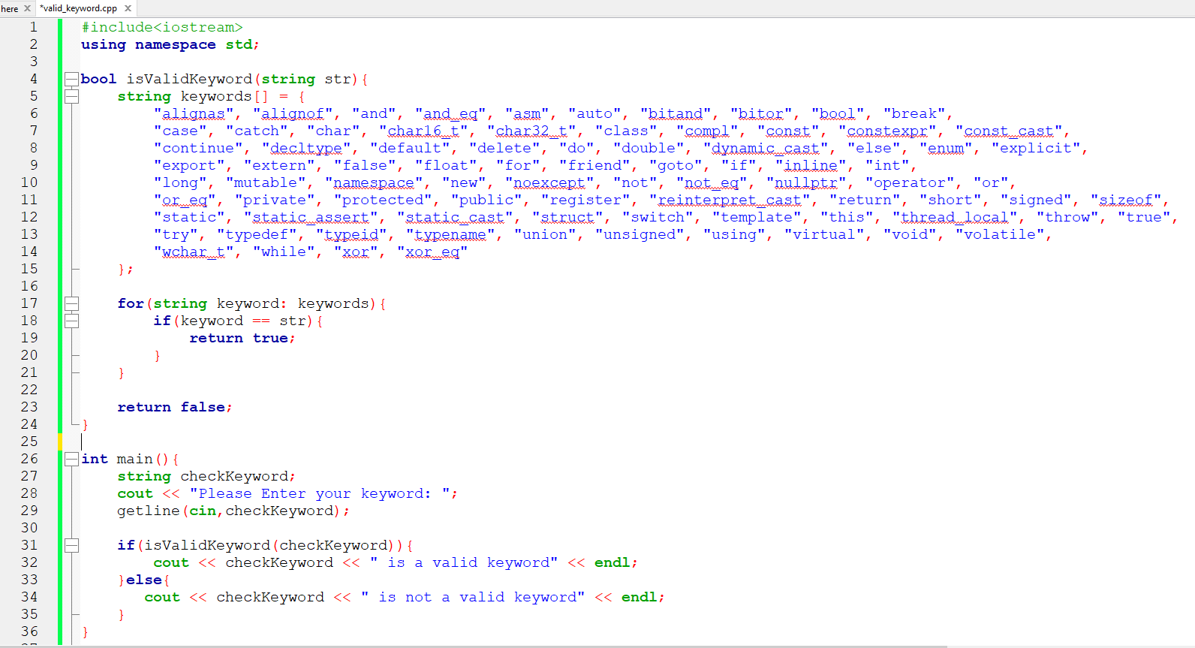

**Input and Output**

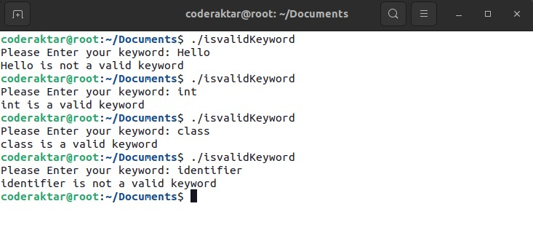

**Conclusion**

This program successfully checks whether a given string is a valid C++ keyword. It employs a predefined list of keywords and utilizes a function to perform the validation. The user-friendly interface enhances ease of use.